Web Application Design Approach (Draft 10/18/18 JdeB)

Useful to follow a standard process or flow when developing any web application. We can deduce one based on the Flask tutorial that creates a miniblog (<http://flask.pocoo.org/docs/1.0/tutorial/> ). Renaming some of the steps, the overall process would be somewhat like the following.

Web App Design Process (implement within a methodology like Agile development, older Waterfall)

1. Define application purpose, audience, client/owner, and objectives. (Project & Themes)
2. Create wireframes with descriptions of linkages and use cases. (Themes, Epics & Stories)
3. Identify major development tasks and order them. (Product Backlog/Stories => Sprints/Scrums)
4. Execute on Tasks including Testing, Approval, Documentation (Scrum Task Board, Artifacts)
5. Move to production (Agile requires working functionality at each Sprint end)

Brief comparison of Waterfall and Agile

<https://manifesto.co.uk/agile-vs-waterfall-comparing-project-management-methodologies/>

Agile Manifesto <http://agilemanifesto.org/>

Scrum Methodology <https://www.scrum.org/>

Scrum Guide <https://www.scrum.org/index.php/resources/scrum-guide>

Organization of an Agile Project <https://manifesto.co.uk/scrum-roles-scrum-team/>

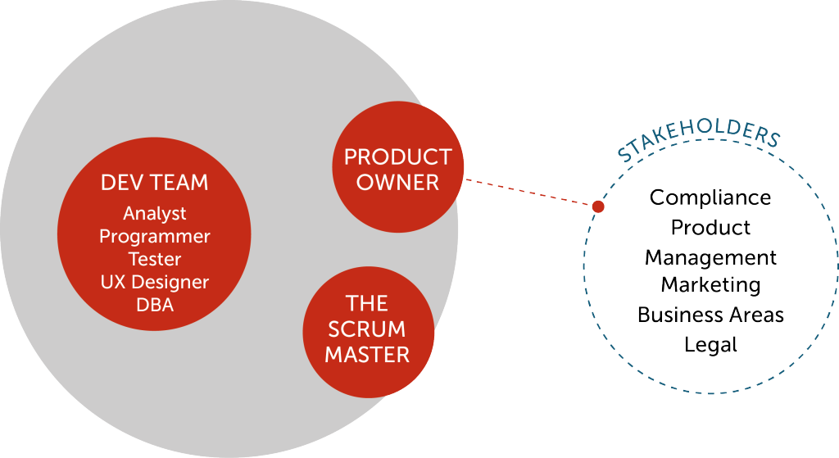

Scrum Master <https://manifesto.co.uk/scrum-roles-scrummaster/>

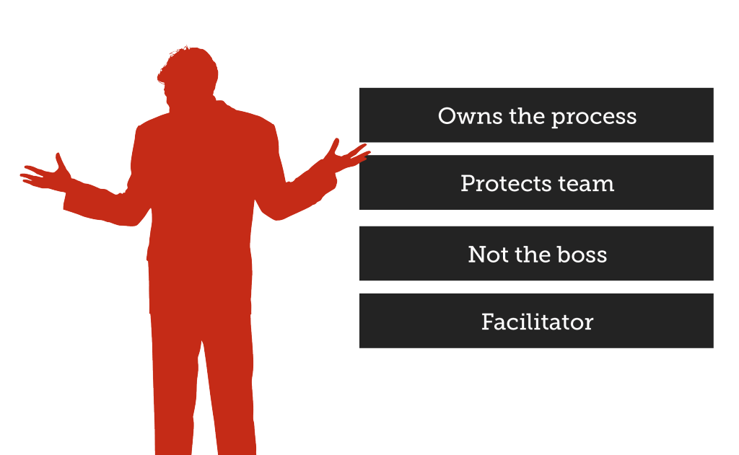

Product Owner <https://manifesto.co.uk/scrum-roles-product-owner/>

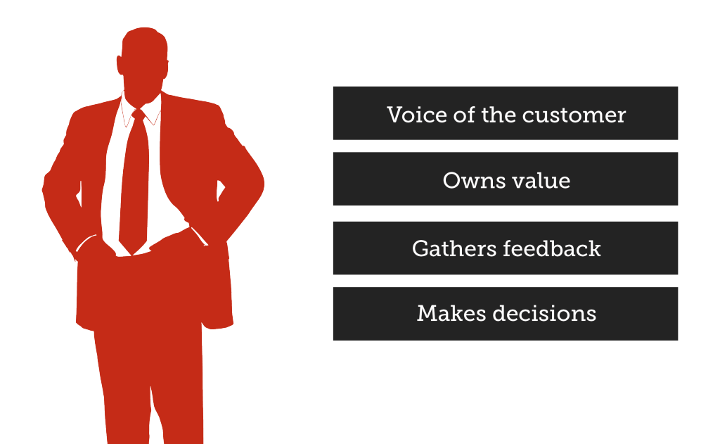

Scrum Task Board <https://manifesto.co.uk/agile-concepts-scrum-task-board/>

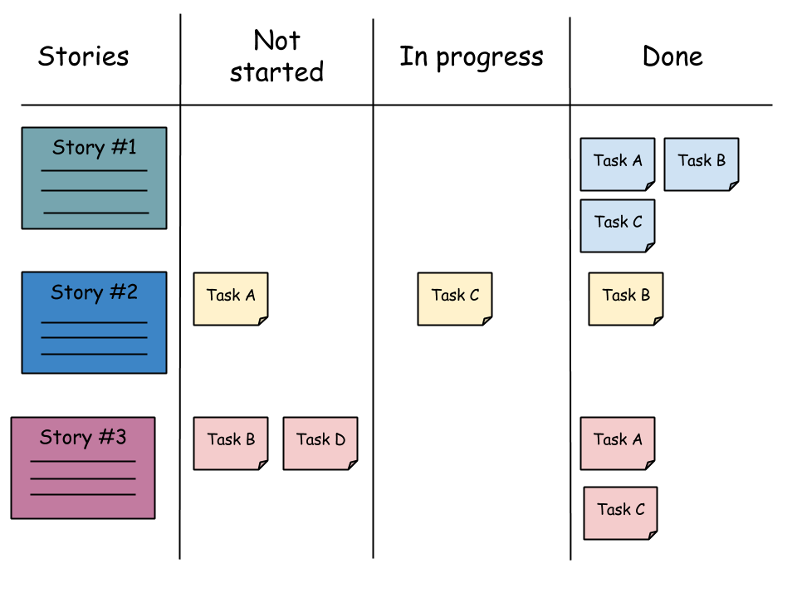

Waterfall <https://manifesto.co.uk/agile-vs-waterfall-comparing-project-management-methodologies/>

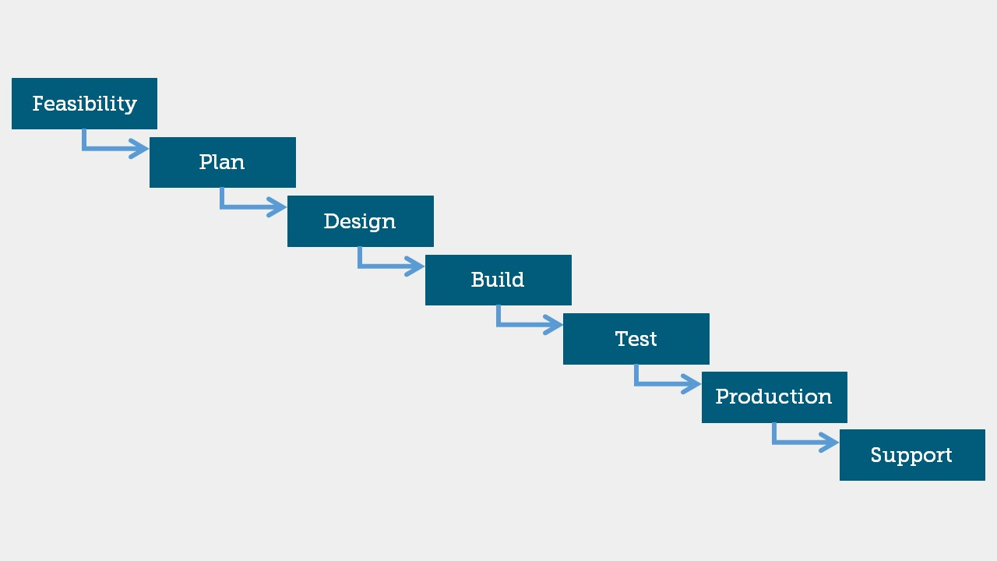

Agile <https://manifesto.co.uk/agile-vs-waterfall-comparing-project-management-methodologies/>

